Practical 2
Relative, Absolute and Mixed References
Problem 1:

A worksheet contains item description and unit cost of 5 items as follows: Calculate the selling price (absolute reference)
Selling price = unit cost * profit%

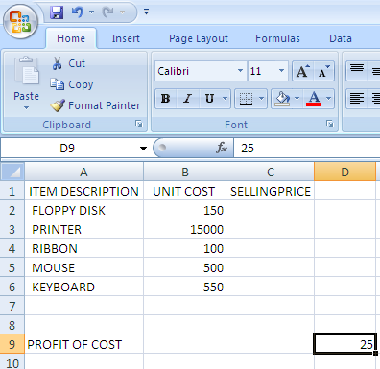

Solution: To calculate selling price
- Click at cell C2
- Type the formula as =B2+B2*$D$9% <enter>
- Click at cell C2 Drag the fill handle up to cell C6.

Problem 2:

A worksheet contains item description, unit cost and profit in % of 5 items as follows: Calculate selling price (relative reference)
Selling price = unit cost * profit

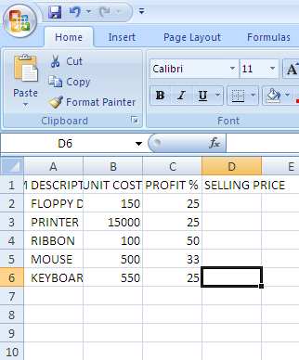

Solution: To calculate selling price
- Click at cell D2
- Type the formula as =B2+B2*C2% <enter>
- Click at cell D2 & drag the fill handle up t D6

Problem 3:

Name, amount, interest rate and period are entered in cell A1 to D10. Calculate simple interest and compound interest in column E & F
Simple interest =amount*rate*period /100
Compound interest = amount (1 + rate /100) ^{period} -amount
Solution:
- Type heading NAME in cell A1
- Enter the data till A10
- Type heading AMOUNT in cell B1
- Enter the data till B10
- Type heading RATE in cell C1
- Enter the data till C10
- Type heading PERIOD in cell D1
- Enter the data till D10
To calculate simple interest
- Type heading SIMPLE INTEREST in E1
- Select E2 and type the formula as =B2*C2*D2/100 <enter>
- Select E2 and drag the fill handle up to E10
To calculate compound interest
- Type heading COMPOUND INTEREST in cell F1
- Select F2 and type the formula as =B2*(1+C2/100)^D2-B2 <enter>
- Select F2 and drag the fill handle up to 10

Problem 4:

Name, amount, interest rate are entered in cell A1 to C10. Calculate simple interest and compound interest in column D & E. period is 7 years
Simple interest =amount*rate*period /100
Compound interest = amount (1 + rate /100) ^{period} –amount
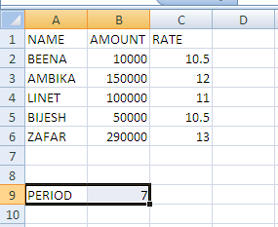

Solution:
- Type heading NAME in cell A1
- Enter the data till A6
- Type heading AMOUNT in cell B1
- Enter the data till B6
- Type heading RATE in cell C1
- Enter the data till C6
- Type period in A9
- And type 7 in B9
- Type heading S.INT D1
- Type heading C.INT E1
To calculate SIMPLE INTEREST
- Select D2 and type the formula as =B2*C2*$B$9/100 <enter>
- Click at D2 and drag the fill handle till D6
To calculate COMPOUND INTEREST
- Select E2 and type the formula =B2*(1+C2/100)^$B$9-B2 <enter>
- Click at E2 and drag the fill handle till E6

Problem 5:
Consider the following worksheet and calculate depreciation by using straight line method
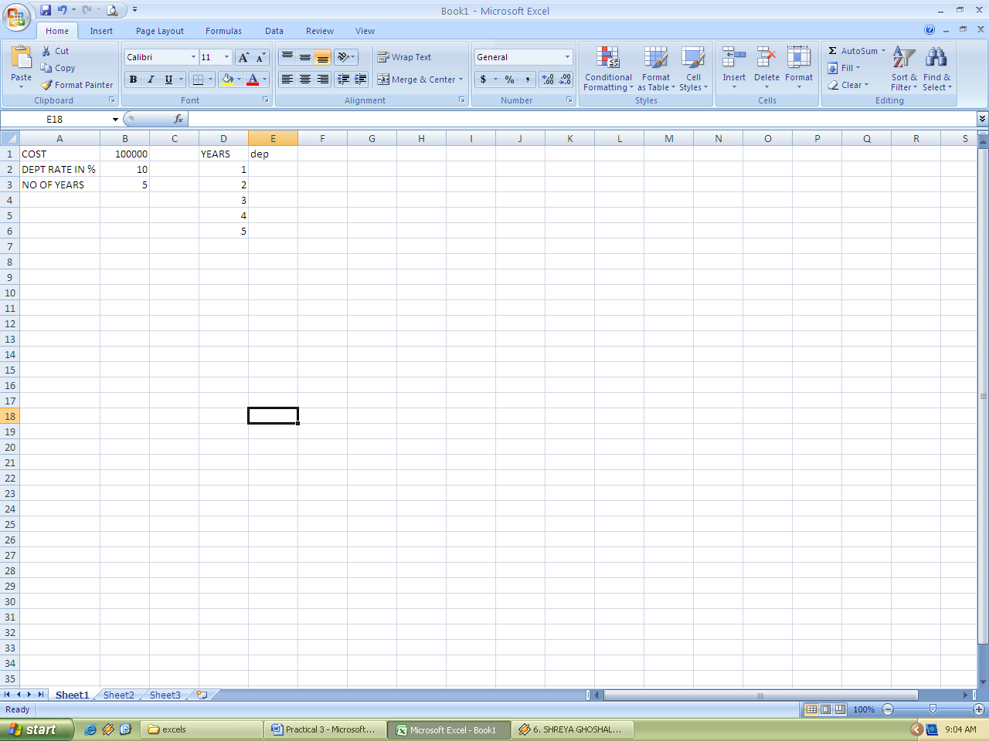

Solution: To calculate depreciation
- Select the cell E2
- Type the formula as =$B$1*$B$2/100 <enter>
- Select the cell E2 & drag the fill handle upto cell E6

Problem 6:
Consider the following worksheet and calculate depreciation by using written down method for each year.
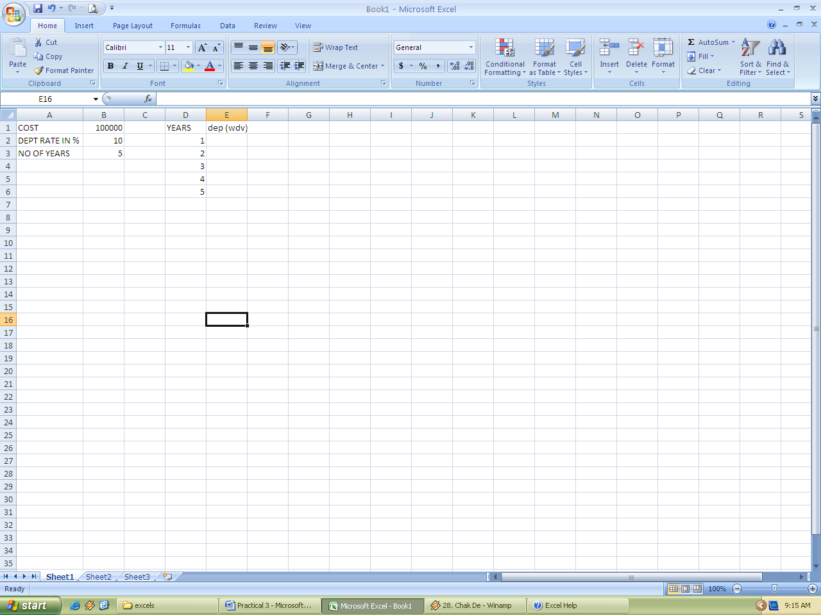
Solution: To calculate depreciation
- Select the cell E2
- Type the formula as =(B$1-SUM(E$1:E1))*B$2/100 <enter>
- Select the cell E2 and drag the fill handle upto E6

Problem 7:
Consider the following worksheet and calculate depreciation by using written down method for each year, also calculate written down value for each year
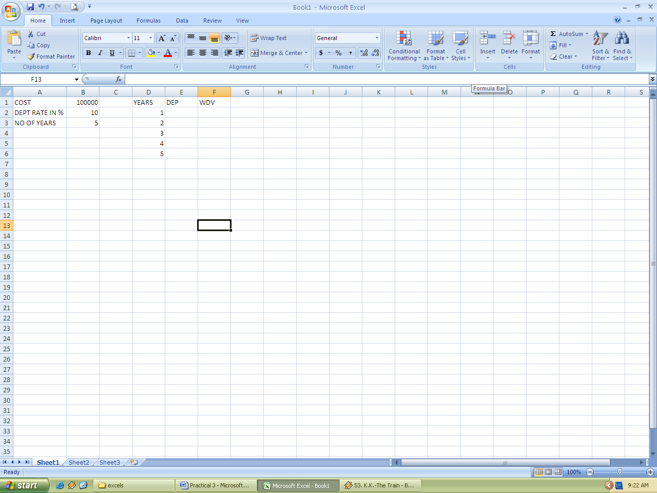
Solution: To calculate depreciation
- Select the cell E2
- Type the formula as =(B$1-SUM(E$1:E1))*B$2/100 <enter>
- Select the cell E2 and drag the fill handle upto E6
To calculate W.D.V in column F
- Select the cell F2
- Type the formula =$B$1-SUM(E$2-E2) <enter>
- Select the cell F2 and drag the fill handle upto F6

